- 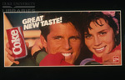
Great new taste
- 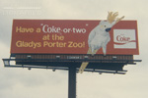
Have a "Coke-or-two" at the Gladys Porter Zoo!
- 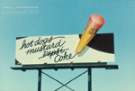
hot dogs, mustard...Coke
- 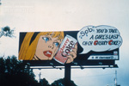
You'd take a girl's last ch-ch Cherry Coke
- 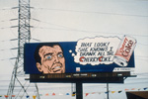
That look! She knows I drank all the Cherry Coke
- 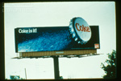
Coke is it!
- 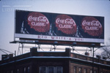
Red, White & You
- 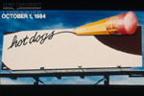
hot dogs
- 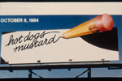
hot dogs, mustard
- 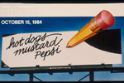
hot dogs, mustard, Pepsi
- 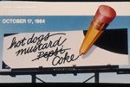
hot dogs, mustard, coke
- 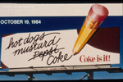
hot dogs, mustard, Coke, Coke is it!
- 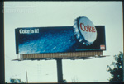
Coke is it!
- 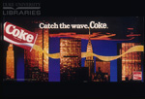
Catch the wave. Coke
- 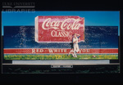
Coca Cola Classic
- 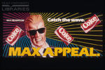
Catch the wave. Max Appeal

- 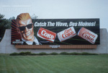
Catch the wave, Des Moines!
- 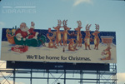
We'll be home for Christmas.
- 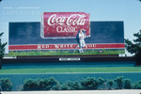
Coca-Cola, Red - White - & You
- 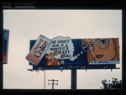
Cherry Coke, He didn't ask if I wanted a Cherry Coke
- 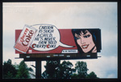
Carlton is such a child. He's never even tried Cherry Coke.

