Two-Column Method
The two-column method of note taking involves dividing the paper into two columns and recording different types of information in each column. It is similar to the Cornell method. The main differences between the two methods are that, with the two-column method, key words and ideas are recorded while taking notes and are not repeated in both columns.
Name
Date

Key  Words | Descriptions
Like the Cornell method, the two-column method allows for easy scanning of notes to locate certain pieces of information. Notes taken using the two-column method may be used as study guides for exam or quiz preparation.
Directions for using the two-column format are as follows:
- Divide Paper
  - Use loose leaf notebook paper and write on one side of the page only.
  - Divide the paper vertically into two columns by drawing lines from top to bottom.
- Documentation
  - Write the following information at the top of each page: student name, course, date, and page number.
- Record Key Words or Ideas
  - Record all key words, ideas, people, or events in the left-hand column.
  - Information in this column must be very brief.
- Record Descriptions or Discussions
  - For each key word or idea, record the corresponding description or explanation next to it in the right-hand column.
- Review and Clarify
  - As soon after class as possible, review the notes in the right column and clarify any ambiguous information.
  - Compare the information with the book and/or other students' notes.
- Study
  - Use both columns of the notes to prepare for quizzes and exams.
- Modify
  - Add extra columns if necessary, depending on the material.
  - For example, you may want to add an extra column for recording relevant information from the textbook at a later date.
Two examples of the two-column method of note taking are provided below.
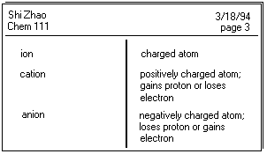
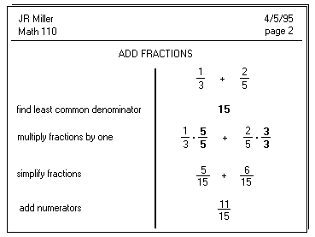
http://www.muskingum.edu/~cal/database/general/notetaking.html

